**Power BI Inflation Analysis: Journeying Through global Economic Terrain**

**Introduction:-**

Inflation, a critical economic indicator, profoundly impacts businesses, consumers, and policymakers worldwide. In this scenario, a multinational corporation operating in diverse markets seeks to optimize pricing strategies, mitigate risks, and make informed investment decisions. Leveraging Power BI's analytical prowess, we delve into inflation data to offer tailored recommendations aligned with each market's unique economic conditions.

Our approach involves data collection, preparation, and modelling to build a robust analysis framework. Through insightful visualizations and strategic recommendations, we aim to equip stakeholders with actionable insights for informed decision-making. Our deliverables include an interactive Power BI dashboard showcasing inflation trends and a comprehensive report summarizing analysis findings and recommendations.

**Scenario 1:** Lack of Data Integration and Standardization

In the context of "Power BI Inflation Analysis: Journeying Through Global Economic Terrain," a key problem might be the lack of standardized data sources and integration methods. Different regions and organizations may report inflation data differently, leading to inconsistencies and challenges in aggregating and analyzing global inflation trends effectively within Power BI. This lack of standardization hampers the ability to provide accurate and comprehensive insights into inflation dynamics worldwide.

**Scenario 2:** Limited Historical Data Accessibility

Another challenge could be the limited accessibility to historical inflation data across various countries and regions. This scarcity of historical data poses a significant obstacle in building robust predictive models within Power BI for forecasting inflation trends accurately. Without a comprehensive historical dataset, analysts may struggle to identify long-term patterns and correlations necessary for making informed decisions and projections.

**Scenario 3:** Complex Economic Interdependencies

The intricate interdependencies among global economies pose a complex challenge in "Power BI Inflation Analysis: Journeying Through Global Economic Terrain." Fluctuations in one country's inflation rate can have ripple effects across other regions, making it difficult to isolate and analyze the drivers of inflation within individual economies. Effectively capturing and analyzing these interdependencies within Power BI requires sophisticated modeling techniques and access to diverse datasets, which may not be readily available or easily integrated into the analysis platform.

**Technical Architecture:**

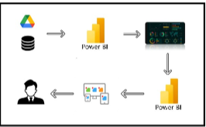

**Project Flow: -**

To accomplish this, we have to complete all the activities listed below,

● Data Collection & Extraction from Database

o Collect the dataset,

o Storing Data in DB

o Perform SQL Operations

o Connect DB with Power Bi

● Data Preparation

o Prepare the Data for Visualization

● Data Visualizations

o No of Unique Visualizations

● Dashboard

o Responsive and Design of Dashboard

● Report

o Responsive and Design of Dashboard

● Performance Testing

o No of Visualizations/ Graphs

● Project Demonstration & Documentation

o Record explanation Video for project end to end solution

* + Project Documentation-Step by step project development procedure

**Milestone 1: Data Collection & Extraction from Database**

Data collection is the process of gathering and measuring information on variables of interest, in an established systematic fashion that enables one to answer stated research questions, test hypotheses, and evaluate outcomes and generate insights from the data.

**Activity 1: Collect the dataset**

Link to download global Inflation Datasetet: [Link](https://www.kaggle.com/datasets/sazidthe1/global-inflation-data)

Link to download Country Region Table.csv file: [Link](https://github.com/lukes/ISO-3166-Countries-with-Regional-Codes/blob/master/all/all.csv)

**Activity 1.1:** Understand the data

Data contains all the meta information regarding the columns described in the CSV files.

Column Description of the Dataset:

1) Country_name: Name of the Country.

2) Inflation Rate: Inflation rate of each country.

3) Region: Region of country which belongs

4) Year: represents the calendar year for which the corresponding inflation data is recorded.

5) AdjustedInflationRate: The 'Adjusted Inflation Rate' column is derived by multiplying the inflation rate by 0.01 .

6) InflationRateCategory:The 'Inflation Rate' column is categorized as high, medium, or low based on predefined thresholds.

**Activity 2: Connect Data with Power BI**

With Power BI, users can seamlessly connect to a wide range of data sources, including databases, cloud services, spreadsheets, and streaming data. This capability allows organizations to consolidate disparate data sources into a single, unified platform, breaking down data silos and enabling holistic analysis.

**Milestone 2: Data Preparation**

Data preparation is a critical phase in the data lifecycle, encompassing activities that transform raw data into a format suitable for analysis. This multifaceted process involves several steps including data cleaning, integration, transformation, and enrichment. Data cleaning involves identifying and rectifying errors, inconsistencies, and missing values within datasets to ensure accuracy and reliability.

**Activity 1: Prepare the Data for Visualization**

Preparing the data for visualization involves cleaning the data to remove irrelevant or missing data, transforming the data into a format that can be easily visualized, exploring the data to identify patterns and trends, filtering the data to focus on specific subsets of data, preparing the data for visualization software, and ensuring the data is accurate and complete. This process helps to make the data easily understandable and ready for creating visualizations to gain insights into the performance and efficiency.

**Milestone 3: Data Visualization**

Data visualization is the process of creating graphical representations of data to help people understand and explore the information. The goal of data visualization is to make complex data sets more accessible, intuitive, and easier to interpret. By using visual elements such as charts, graphs, and maps, data visualizations can help people quickly identify patterns, trends, and outliers in the data.

**Activity 1.1: Average Inflation Rate**

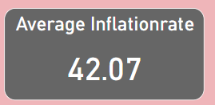

**Activity 1.2: Maximum Inflation Rate**

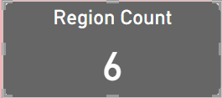

**Activity 1.3: Total Number of Regions**



**Activity 1.4: Inflation_Rate change over a year**

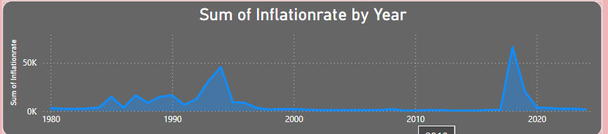

**Activity 1.5: Distribution Of Inflationrate Categories**

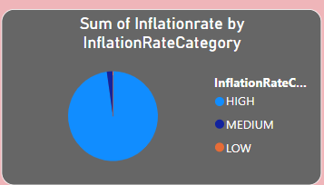

**Activity 1.6:  Filter applied On Country Column**

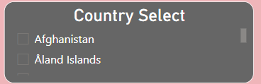

**Activity 1.7: Maximum Inflation Year**

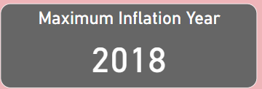

**Activity 1.8:  inflation rate and adjusted inflation rate change over years**

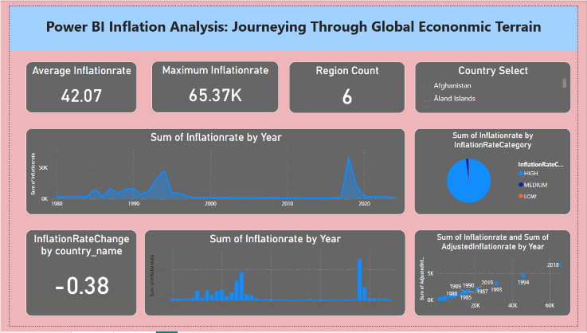

**Activity 1.9: Count of Region By Country**

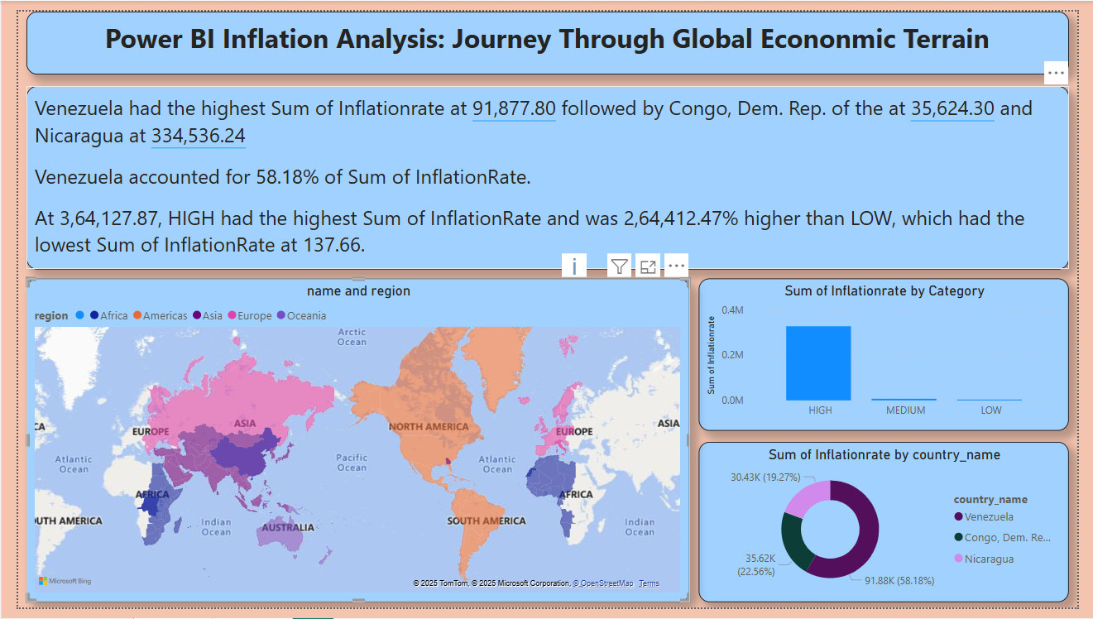

**Activity 1.10: Inflation Rate Distribution**



**Activity 1.11: Top 3 Inflation rate Countries**



**Milestone 4: Dashboard**

A dashboard is a graphical user interface (GUI) that displays information and data in an organized, easy-to-read format. Dashboards are often used to provide real-time monitoring and analysis of data and are typically designed for a specific purpose or use case. Dashboards can be used in a variety of settings, such as business, finance, manufacturing, healthcare, and many other industries. They can be used to track key performance indicators (KPIs), monitor performance metrics, and display data in the form of charts, graphs, and tables.

**Activity :1- Responsive and Design of Dashboard**

The responsiveness and design of a dashboard for Power BI Inflation Analysis Dashboard effectively presents global inflation trends through a user-friendly, interactive, and data-driven approach. It highlights key metrics such as average inflation, maximum inflation rate, and inflation trends over time using clear visualizations like line charts, bar graphs, and pie charts. The dashboard is designed for easy navigation, interactivity, and customization, allowing users to filter data by country and analyze inflation patterns dynamically. With a well-structured layout, contrasting colors for readability, and a focus on actionable insights, it enhances decision-making and economic analysis.

Once you have created views on different sheets in Power Bi you can pull them into a dashboard.

Explanation video link:

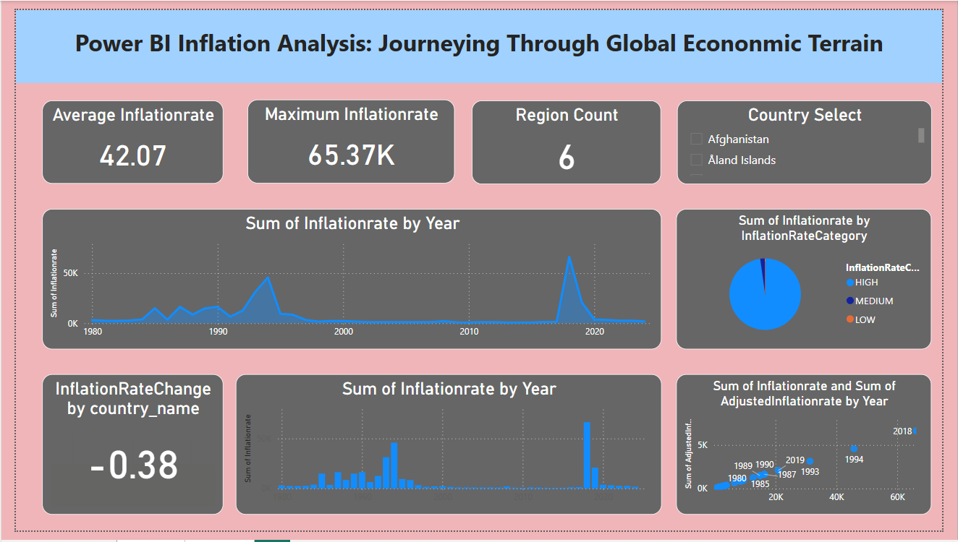

**Milestone 5: Report**

A data report is a way of presenting data and analysis in a narrative format, with the goal of making the information more engaging and easier to understand. A data story typically includes a clear introduction that sets the stage and explains the context for the data, a body that presents the data and analysis in a logical and systematic way, and a conclusion that summarizes the key findings and highlights their implications. Data Report can be told using a variety of mediums, presentations, interactive visualizations, and videos



**Milestone 7: Performance Testing**

Performance testing is a crucial aspect of software development aimed at evaluating the speed, responsiveness, stability, and scalability of an application under various workload conditions. It involves simulating real-world usage scenarios to assess how the system behaves and performs under stress, peak loads, or normal conditions.

**Activity 1: Utilization of Data Filters**

The utilization of data filters plays a pivotal role in streamlining information processing and analysis across various domains. By selectively extracting or excluding specific data points based on predefined criteria, filters enable efficient data management and enhance decision-making processes.

**Amount of Data Loaded:**

"Amount of Data Loaded" refers to the quantity or volume of data that has been imported, retrieved, or loaded into a system, software application, database, or any other data storage or processing environment. It's a measure of how much data has been successfully processed and made available for analysis, manipulation, or use within the system.

**Activity 2 : No of Visualizations/ Graphs**

1. Average Inflation Rate

2. Maximum Inflation Rate

3. Total Number of Regions

4.  InflationRate change over a year

5. Distribution Of Inflationrate Categories.

6. Filter applied On Country Column

7. Maximum Inflation Year

8. Inflation rate and adjusted inflation rate change over years

9. Count of Region By country

10. Inflation rate  Distribution

11. Inflation rate Countries

**Milestone 8: Project Demonstration & Documentation**

Below mentioned deliverables to be submitted along with other deliverables

**Activity 1:- Record explanation Video for project end to end solution**

Creating a record explanation video for a project's end-to-end solution is crucial for ensuring clarity and transparency in its implementation. This video serves as a comprehensive guide, detailing every aspect of the project from inception to completion.

**Activity 2:- Project Documentation-Step by step project development procedure**

Create document as per the template provided

**Demonstration Video Link: -**

<https://drive.google.com/file/d/1l7_t7ftiNfwB7Rw1uTrzyATCQjh0HUDz/view?usp=drive_link>